* **HYBRID OFF-GRID SYSTEM INPUTS-LOS ANGELES**

|  |  |  |
| --- | --- | --- |
| Parameters | Value | Ref. |
| Project life time | 25 | - |
| Nominal discount rate | 4.5% | [1] |
| Expected inflation rate | 2% | [2] |
| Tax rate (US national average) | 5.8% | [3] |
| Maximum loss of power supply probability | 1.1% | - |
| Minimum Renewable Energy Capacity | 75% | - |
| Installation cost (per kW) | 305.57 $ | [3] |
| Overhead cost (per kW) | 549.87 $ | [3] |
| Permitting and Inspection (per kW) | 205.95 $ | [3] |
| Electrical BoS (per kW) | 399.11$ | [3] |
| Structural BoS (per kW) | 89.90 $ | [3] |
| PV Capital cost per kW | 314.18 $ | [3] |
| Replacement Cost of PV modules per kW | 314.18 $ | [3] |
| PV O&M cost ($/year/kW) | 29.49 $ | [3] |
| PV life time | 25 | - |
| DG Capital cost per kW | 308.64 $ | [4] |
| Replacement Cost of DG modules per KW | 308.64 $ | [4] |
| DG life time | 24000 hours | [5] |
| Diesel fuel cost per liter | 1.39 $ | [6] |
| DG O&M+ running cost ($/op.h) | 0.064 $ | [5] |
| BT Capital cost per kW | 234.56 $ | [3] |
| Replacement Cost of BT per kWh | 234.56 $ | [3] |
| BT life time | 15 years (Li ion) | [7] |
| Inverter Capital cost per kW | 229.38 $ | [3] |
| Replacement Cost of Inverter modules Per kW | 229.38 $ | [3] |
| Inverter life time | 25 | - |
| Charger Capital cost | 149.99 $ | [8] |
| Charger Replacement Cost | 149.99 $ | [8] |
| PV tilt angle in Los Angles | 19 | [9] |

* **UTILITY RATES-GRID** [10]

Base Charges:

$2.30/month (tier 1)

$7.90/month (tier 2)

$22.70/month (tier 3)

*First tier rates:*

$0.19488/kWh (Jan - Mar)

$0.19375/kWh (Apr - May)

$0.19375/kWh (Jun)

$0.18179/kWh (Jul - Sep)

$0.19192/kWh (Oct - Dec)

*Second tier rates:*

$0.25347/kWh (Jan - Mar)

$0.25234/kWh (Apr - May)

$0.25234/kWh (Jun)

$0.24038/kWh (Jul - Sep)

$0.25051/kWh (Oct - Dec)

*Third tier rates:*

$0.25347/kWh (Jan - Mar)

$0.25234/kWh (Apr - May)

$0.33935/kWh (Jun)

$0.32739/kWh (Jul - Sep)

$0.25051/kWh (Oct - Dec)

* **RESULTS**
* ***Off-grid system***

System Size

Cpv (kW) = 7

Cwt (kW) = 0

Cbat (kWh) = 23

Cdg (kW) = 1

Cinverter (kW) = 1.9521

Result:

NPC = 33674.5877 $

LCOE = 0.23153 $/kWh

Operation Cost = 716.258 $

Initial Cost = 20403.686 $

RE = 91.065 %

Total operation and maintenance cost = 4047.8469 $

PV Power = 13053.2685 kWh

WT Power = 0 kWh

DG Power = 701.381 kWh

LPSP = 1.0139 %

Excess Electricity = 3225.3793 kWh

Total Money paid by the user= 33674.5877 $

Total fuel consumed by DG = 229.493 (kg/year)

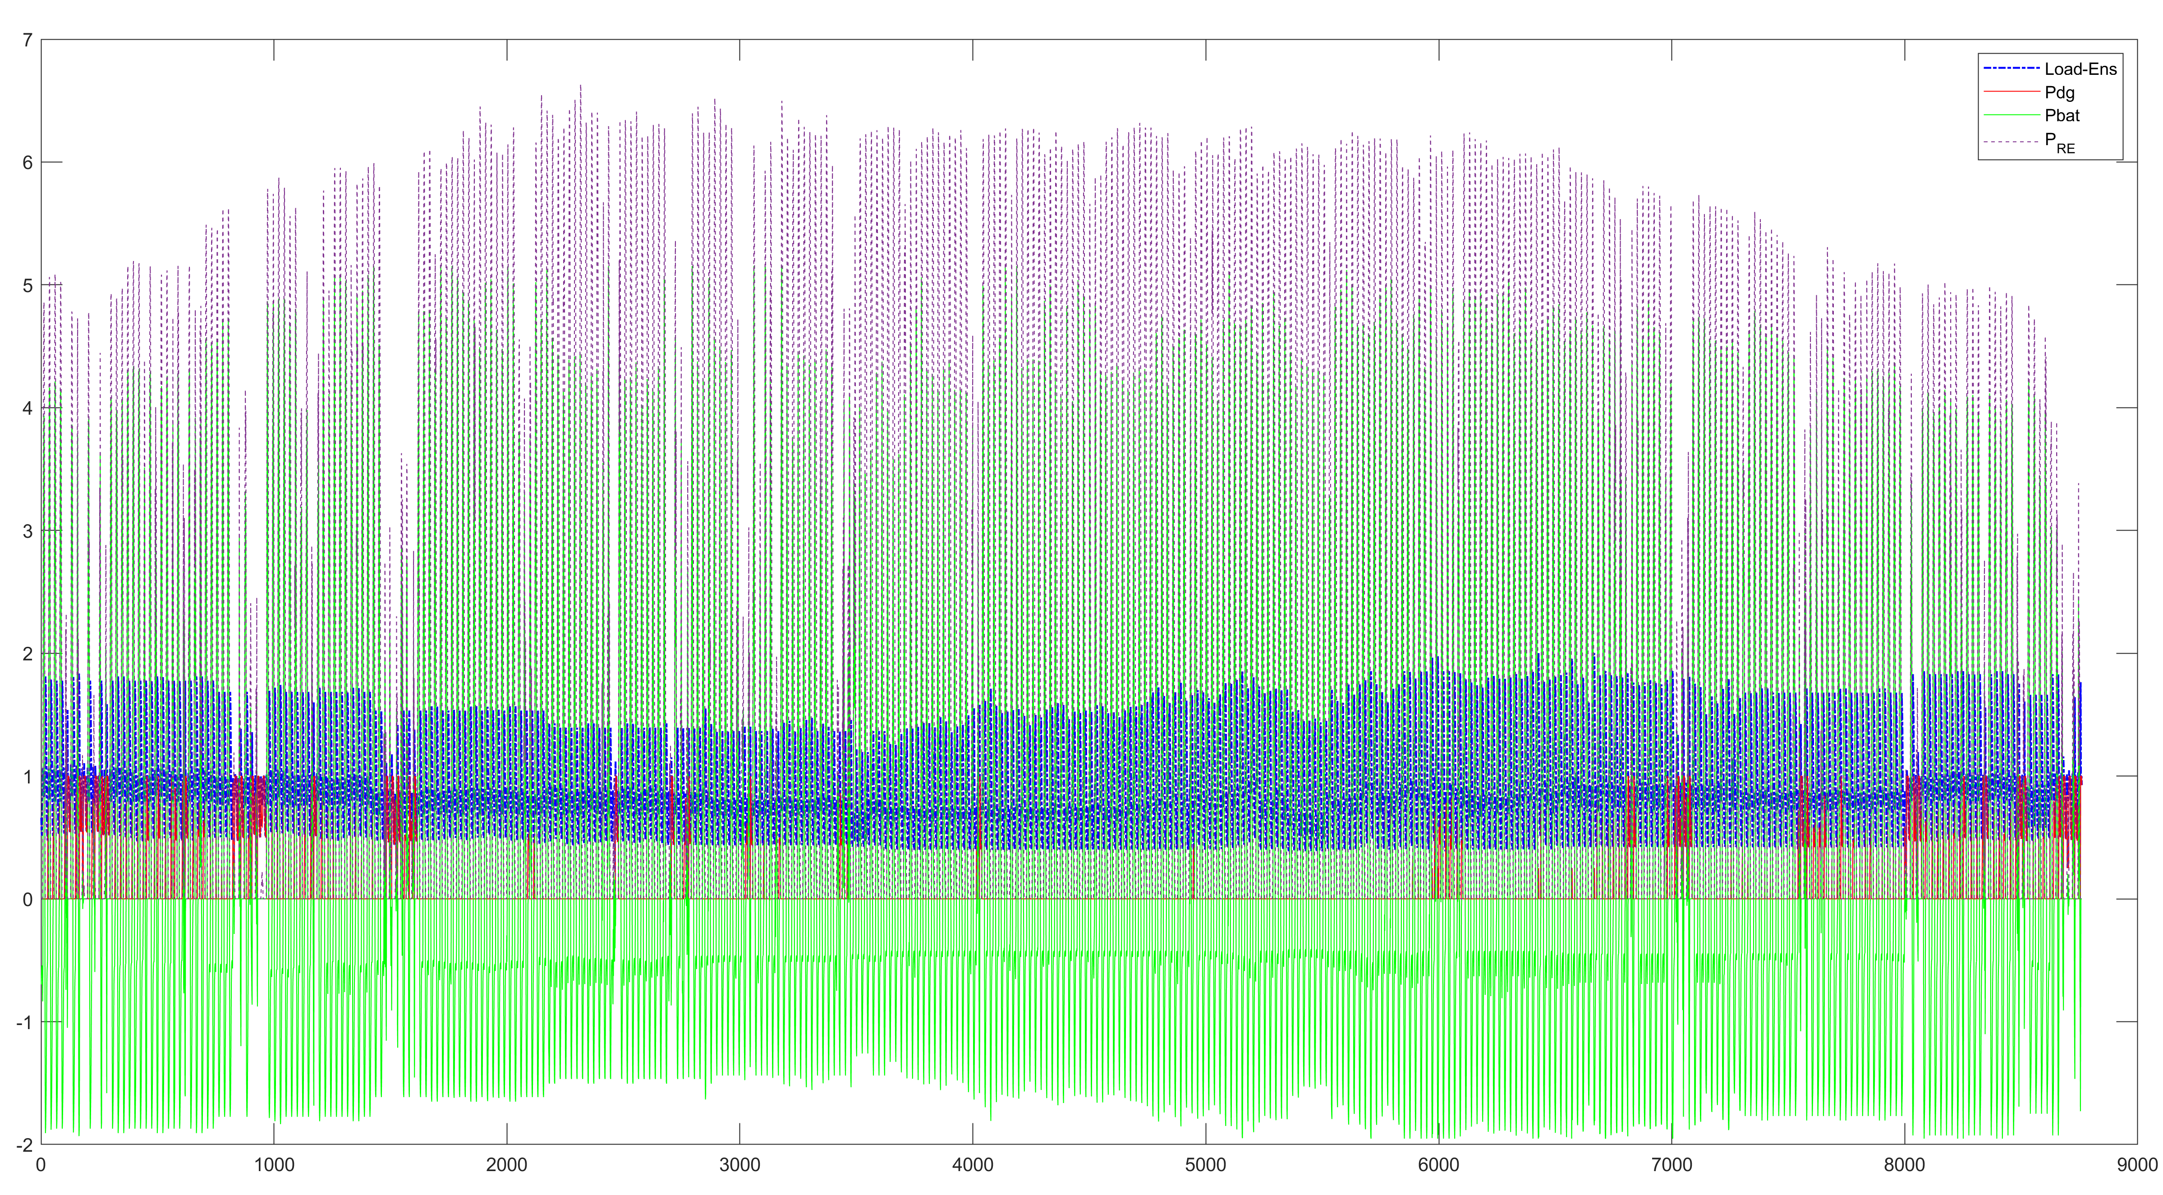

**Fig.1.**Energy distribution in the hybrid system throughout the year

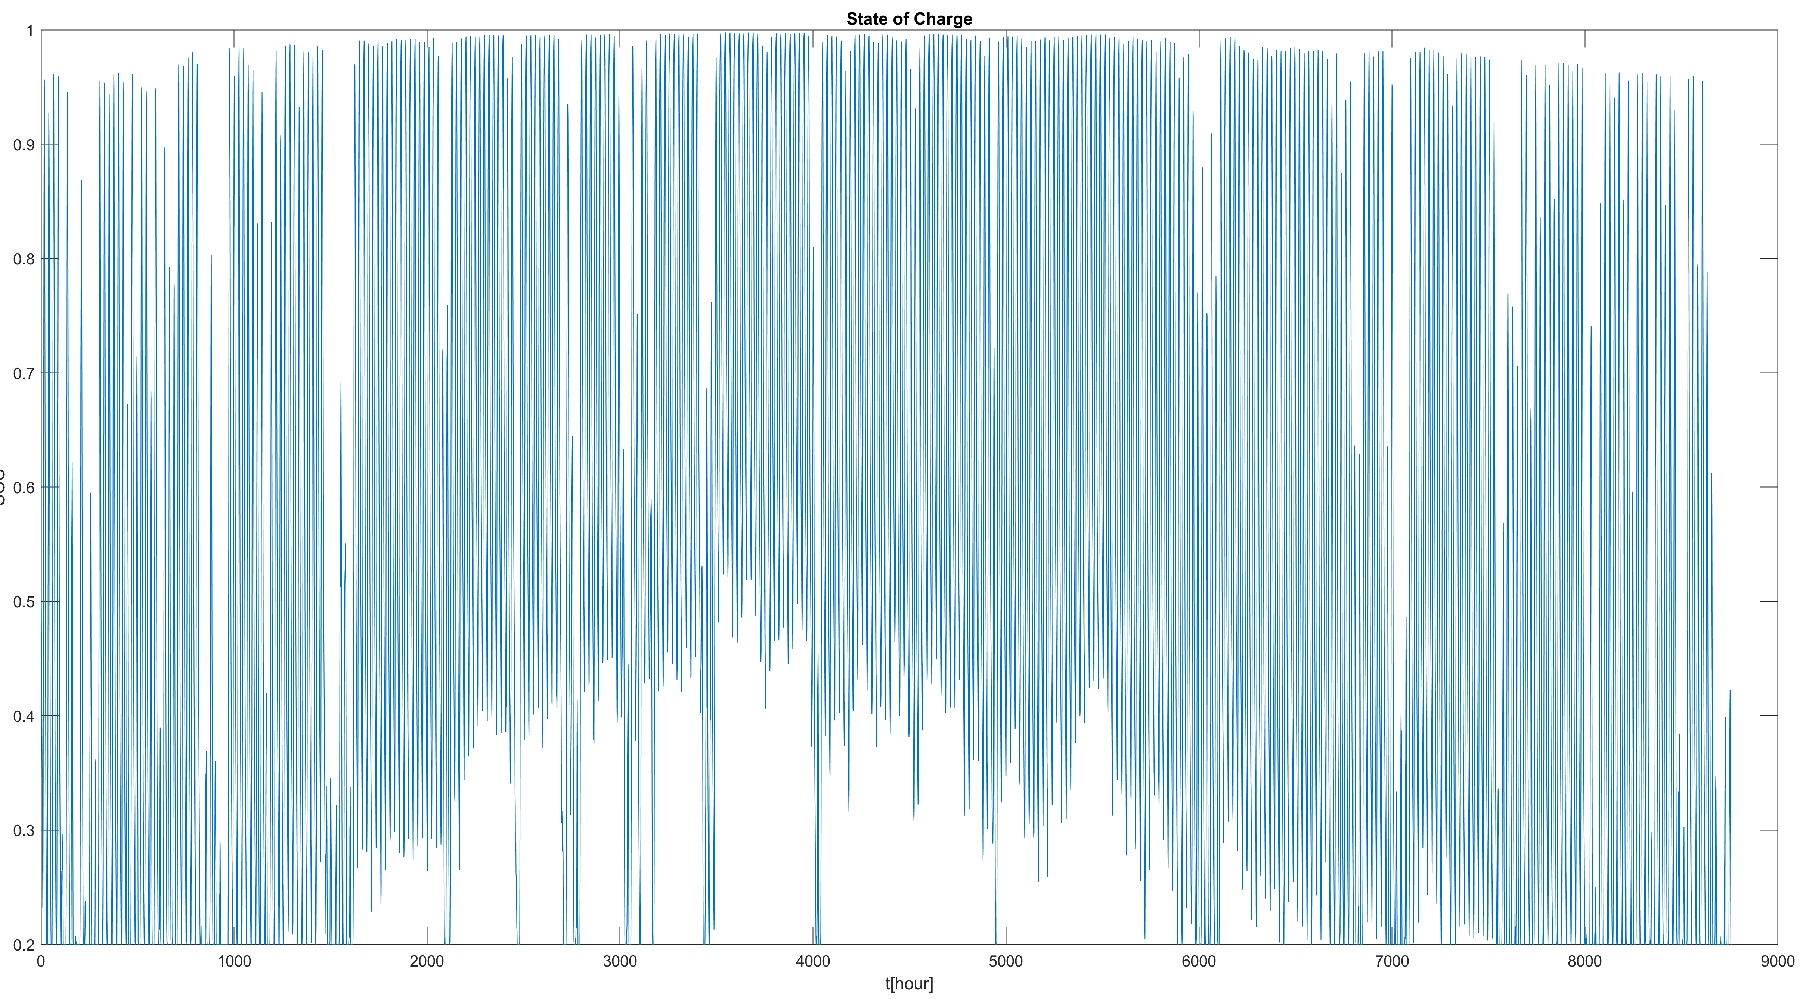

**Fig.2.**Sate of charge of battery throughout the year

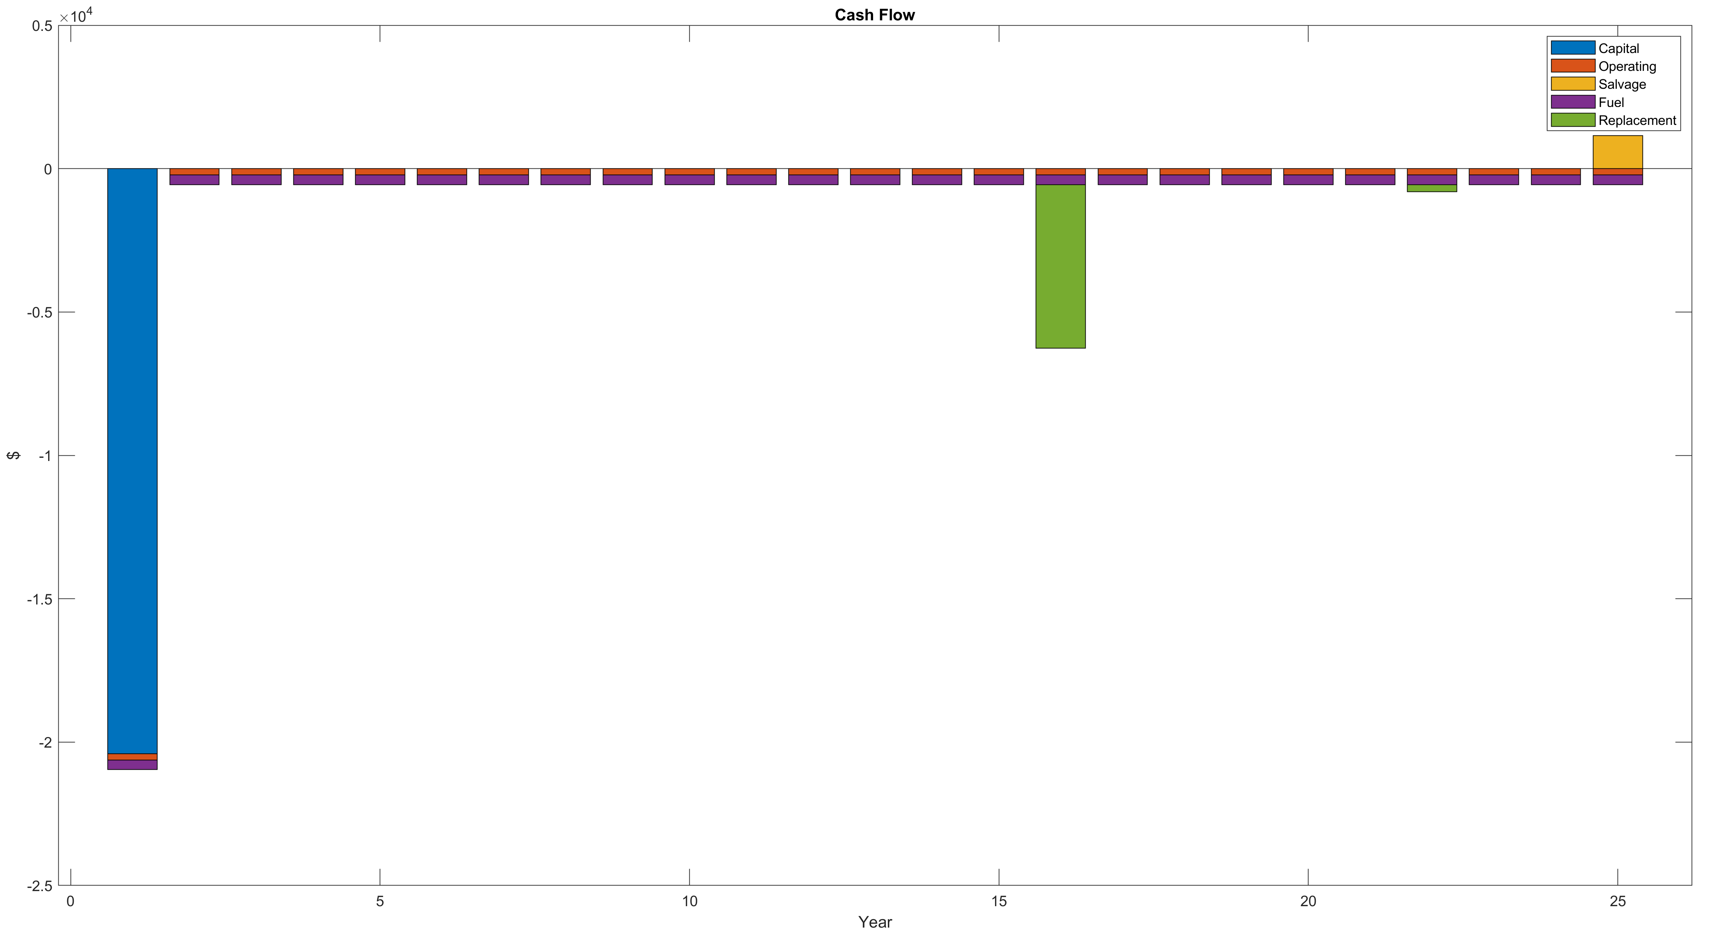

**Fig.3.**Cash flow of project

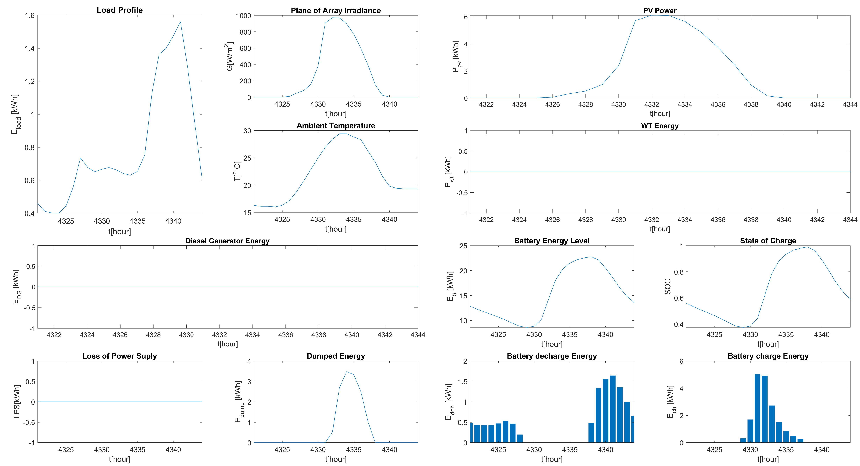

**Fig.4.**Results for 181th day of year

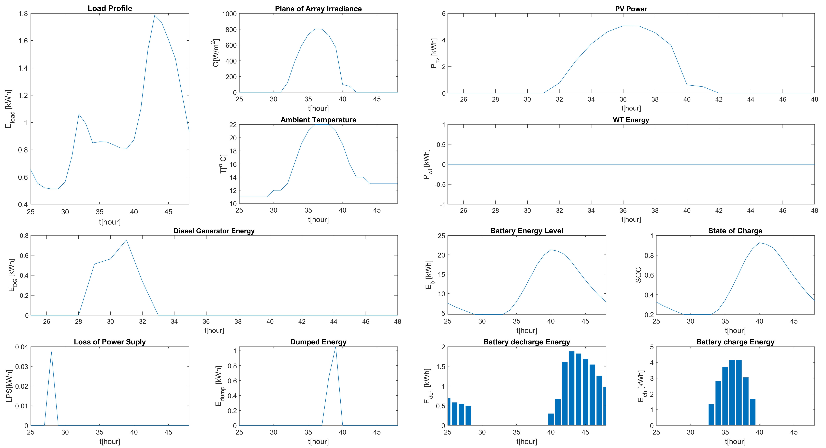

**Fig.5.**Results for 2th day of year

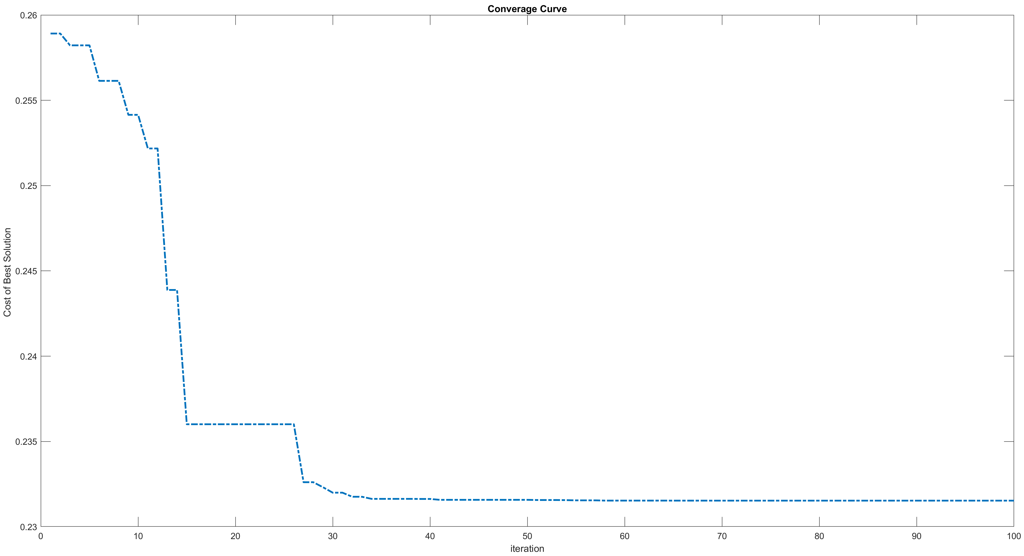

**Fig.6.**Convergance curve for optimization

* ***Only Grid connection***

NPC = 38332.3709 $

LCOE = 0.26088 $/kWh

Operation Cost = 2068.8772 $

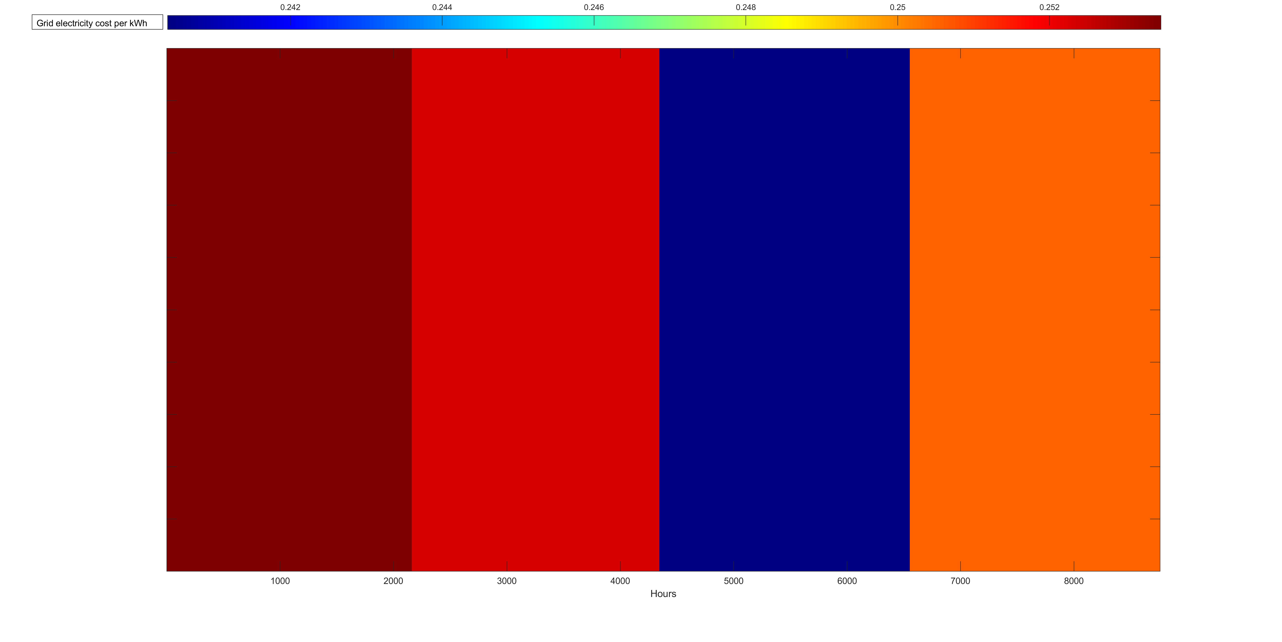

**Fig.7.**Color map of electricity prices throughout the year

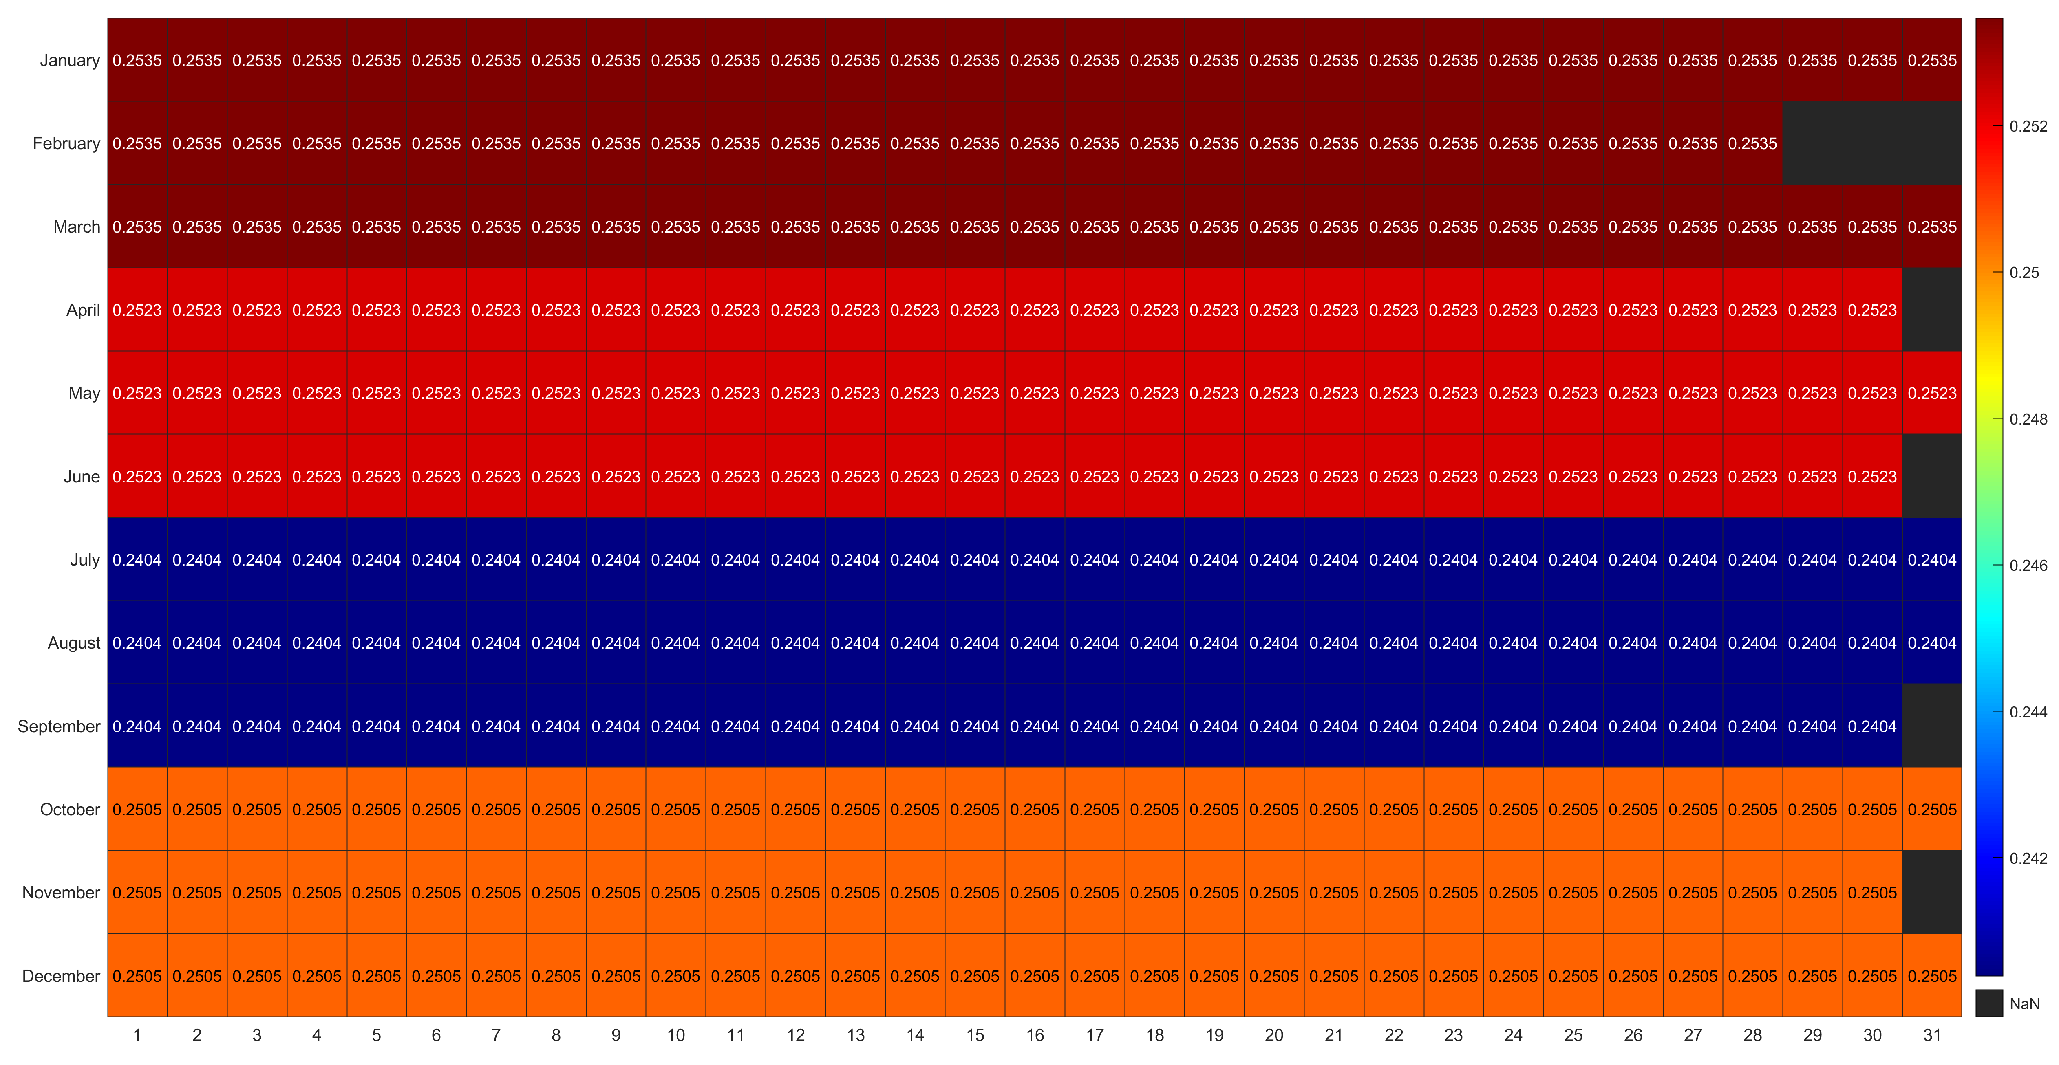

**Fig.8.**Color table of electricity prices throughout the year

**REFERENCES**

[1] “US Discount Rate.” https://ycharts.com/indicators/us_discount_rate#:~:text=US%20Discount%20Rate%20is%20at,long%20term%20average%20of%201.92%25. (accessed Jan. 13, 2023).

[2] “Projected U.S. inflation rate 2010-2027 | Statista.” https://www.statista.com/statistics/244983/projected-inflation-rate-in-the-united-states/ (accessed Jan. 13, 2023).

[3] V. Ramasamy *et al.*, “US Solar Photovoltaic System and Energy Storage Cost Benchmarks, With Minimum Sustainable Price Analysis: Q1 2022,” National Renewable Energy Lab.(NREL), Golden, CO (United States), 2022.

[4] “iGen2200 Inverter Generator.” https://westinghouseoutdoorpower.com/products/igen2200-inverter-generator (accessed Jan. 13, 2023).

[5] A. L. Bukar, C. W. Tan, L. K. Yiew, R. Ayop, and W.-S. Tan, “A rule-based energy management scheme for long-term optimal capacity planning of grid-independent microgrid optimized by multi-objective grasshopper optimization algorithm,” *Energy Convers. Manag.*, vol. 221, p. 113161, Oct. 2020, doi: 10.1016/j.enconman.2020.113161.

[6] “Gasoline and Diesel Fuel Update.” https://www.eia.gov/petroleum/gasdiesel/index.php (accessed Jan. 13, 2023).

[7] N. Narayan, T. Papakosta, V. Vega-Garita, J. Popovic-Gerber, P. Bauer, and M. Zeman, “A simple methodology for estimating battery lifetimes in Solar Home System design,” in *2017 IEEE AFRICON*, Sep. 2017, pp. 1195–1201. doi: 10.1109/AFRCON.2017.8095652.

[8] “Amazon.com : BougeRV 40A MPPT Solar Charge Controller, w/ Remote APP Control, Backlit LCD Display, Temperature Sensor, 12V/24V/36V/48V Battery Regulator, for Lithium, SLD, AGM, FLD, Gel Battery, Negative Ground : Patio, Lawn & Garden.” https://www.amazon.com/BougeRV-Controller-Temperature-Regulator-Negative/dp/B09JZGBDPB (accessed Jan. 13, 2023).

[9] “Best Solar Panel Angle: How Do You Find It — And Does it Matter?” https://www.solarreviews.com/blog/best-solar-panel-angle (accessed Jan. 13, 2023).

[10] “Los Angeles Utility Rates.” [Online]. Available: https://www.cdtfa.ca.gov/taxes-and-fees/rates.aspx